Procedure to run the Concrete Transport Properties neural network
“ANNcoventry v2.0”

Juan Lizarazo Marriaga^{a,b}, Peter Claisse^{b}

ª Departamento de Ingeniería Civil, Universidad Nacional, Bogotá, Colombia. lizarazj@coventry.ac.uk
^{b} Materials Applied Research Group, Coventry University COV 5FB, UK. P.Claisse@coventry.ac.uk

With the aim to give the possibility to all the concrete research community of using a novel technique to optimize the chloride related properties of a concrete sample is presented in this paper as a source open, a summary of the procedure necessary to run the model and the network file built under Matlab®. The method used to optimize the transport related properties of a concrete sample during a 6 hours ASTM C1202 migration test is a back propagation artificial neural network (ANN), where as inputs are necessary experimental observations of current and membrane potential under the conditions of the standard test. The theoretical discussion of the method is presented in reference 1 and details of the experiments are presented in reference 2.

1. Artificial Neural Network

The Artificial Neural Network uses a multilayer architecture: Six neurons define the input layer, corresponding to values of the current and the mid-point membrane potential at different times. A middle hidden layer has 3 neurons, and the output layer output has 7 neurons corresponding to the intrinsic diffusion coefficients of Cl⁻, OH⁻, Na⁺ and K⁺, the porosity, the hydroxide composition in the pore solution at the start of the test, and the binding capacity factor for chloride ions.

Figure 1 Multilayer neural architecture used
2. Input layer

From the standard ASTM-C1202 experiment the transient current and the mid point membrane potential are obtained. Below is shown a detailed procedure to obtain the inputs of the network with the materials presented in reference 1.

- Measure experimentally the physical current and the midpoint membrane potential.

Figure 2 Membrane potential and current measured

- Obtain values of membrane potential at 1.2, 3.6, and 6 hours, and current at 0, 3.6, and 6 hours.

 | Voltaje MP [V] |  |  | Current [mA]
Time [s] | 1.2 | 3.6 | 6.0 | 0.0 | 3.6 | 6.0
OPC 4 | 0.7215 | 2.4105 | 3.7850 | 140.4 | 203.9 | 220.5
OPC 5 | 0.0365 | 2.3885 | 3.2730 | 199.4 | 342.2 | 386.1
OPC 6 | -1.3135 | 2.4760 | 6.7320 | 272.5 | 474.5 | 535.4

Table 1 Values of current and membrane potential at specific times

- To feed the neural network it is necessary normalize the data between -1 and +1 in order to avoid the influence of the scale of the physical quantities. A linear relationship is used to find the equivalence between the real coordinate systems and the natural systems (-1 to +1).

Vmin
V
Vmax
Real scale

Normalized scale
-1
ū
+1

$$\overset{−}{u}=\frac{2(V−V_{\text{avg}})}{V_{\text{max}}−V_{\text{min}}}$$

The corresponding constants to normalize the input experimental data are:

 | Voltage MP [V] |  |  | Current [mA]
Time [s] | 1.2 | 3.6 | 6.0 | 0.0 | 3.6 | 6.0
V_{max} | 2.20 | 6.48 | 7.56 | 298.40 | 552.34 | 512.24
V_{min} | -4.99 | -9.79 | -11.26 | 1.22 | 1.20 | 1.09
V_{avg} | -1.40 | -1.66 | -1.85 | 149.81 | 276.77 | 256.67
L | 7.19 | 16.28 | 18.82 | 297.18 | 551.14 | 511.15

Table 2 Transformation matrix used to normalize the input data

The corresponding normalized values of membrane potential and electrical current are shown in table 3.

 | Membrane Potential |  |  | Current
Time [s] | 1.2 | 3.6 | 6.0 | 0.0 | 3.6 | 6.0
OPC 4 | 0.589 | 0.500 | 0.599 | -0.064 | -0.264 | -0.142
OPC 5 | 0.399 | 0.497 | 0.544 | 0.333 | 0.237 | 0.506
OPC 6 | 0.023 | 0.508 | 0.912 | 0.826 | 0.718 | 1.090

Table 3 Values of current and membrane potential normalized

3. Obtaining the transport related properties

- Open Matlab® and type “nntool” to use the graphic interface of the neural network toolbox.

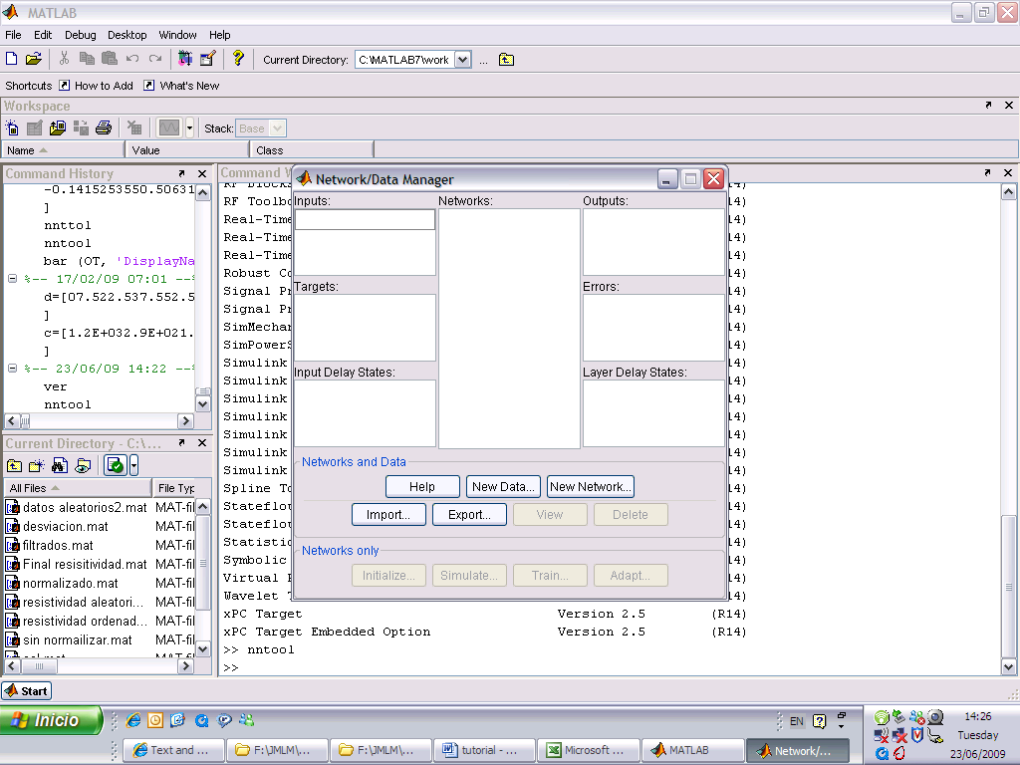

Figure 3 Screen of the Matlab® Neural Network tool box
- Load the network file “ANNcoventry V2.0” to the Matlab® workspace and import that file to the network/Data manager. Create a matrix in the workspace with the inputs values and import it to the network/Data manager. Notice that the input data needs to be entered as matrix of dimension m_{x}n; m is always 6 (6 input neurons) and n is the number of mixes optimized (in this example 3). In this example the input matrix correspond to the table 3 transposed.

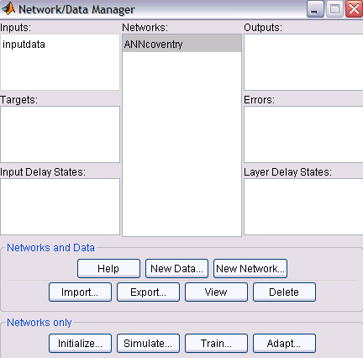

Figure 4 Screen of the network/Data manager

- Open the window Simulate of the network and select as input the matrix “inputdata”. To run click on simulate network. The outputs are saved in the network/Data manager and should be exported to the Matlab workspace.

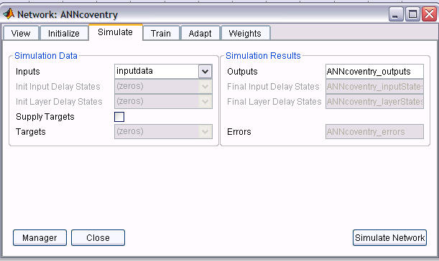

Figure 5 Simulation of the data

- From Matlab® the output matrix has a dimension m_{x}n; m is always equal to 7 because in the output layer there are 7 neurons and n is equal to the number of mixes analyzed (in this case 3). Notice that the data is normalized, and then it is necessary to transform it to its real scale.

 |  | Mix 0.4 | Mix 0.5 | Mix 0.6
OH Concentration |  | -0.15387 | 0.26557 | 0.86461
Cl Diffusion Coef. |  | -0.57714 | -0.46121 | -0.35184
OH Diffusion Coef. |  | -0.83219 | -0.84062 | -0.84619
Na Diffusion Coef. |  | -0.9479 | -0.8947 | -0.8162
K Diffusion Coef. |  | -0.98718 | -0.94098 | -0.85541
CL Capacity factor |  | -0.70277 | -0.75393 | -0.80106
 | Porosity | -0.01296 | 0.12976 | 0.22695

Table 4 Outputs of the network (normalized)

- Each property is converted to its real scale with the following equation and transformation matrix.

$$V=\frac{\overset{−}{U}({\overset{−}{U}}_{\text{max}}−{\overset{−}{U}}_{\text{min}})}{2}+{\overset{−}{U}}_{\text{avg}}$$

 | OH conc | D_{Cl} | D_{OH} | D_{Na} | D_{k} | Cap Cl | porosity
Ū_{max} | 550 | 9.E-10 | 9.E-10 | 8.E-10 | 4.E-10 | 2 | 0.30
Ū_{min} | 30 | 7.E-12 | 3.E-12 | 2.E-12 | 2.E-12 | 0.16 | 0.05
Ū_{avg} | 290 | 4.54E-10 | 4.52E-10 | 4.01E-10 | 2.01E-10 | 0.896 | 0.18
L | 520 | 8.93E-10 | 8.97E-10 | 7.99E-10 | 3.98E-10 | 1.47 | 0.25

Table 5 Transformation matrix used to find the real data

Finally, the optimized transport related properties are computed:

 | OH conc  [mol/m3] | D_{Cl}  [m2/s] | D_{OH}  [m2/s] | D_{Na}  [m2/s] | D_{k}  [m2/s] | Cap Cl | porosity
OPC 4 | 249.994 | 1.96E-10 | 7.83E-11 | 2.23E-11 | 4.55E-12 | 0.379 | 0.173
OPC 5 | 359.048 | 2.48E-10 | 7.45E-11 | 4.35E-11 | 1.37E-11 | 0.341 | 0.191
OPC 6 | 514.799 | 2.96E-10 | 7.20E-11 | 7.49E-11 | 3.08E-11 | 0.306 | 0.203

Table 6 Final transport related properties

4. References

- Lizarazo-Marriaga J., Claisse P., ‘Determination of the concrete chloride diffusion coefficient based on an electrochemical test and an optimization model’. Paper submitted to Materials Chemistry and Physics.

- Lizarazo-Marriaga J., Claisse P., ‘Effect of the non-linear membrane potential on the migration of ionic species in concrete’, Electrochim. Acta 54 (10) (2009) 2761-2769.

- Lizarazo-Marriaga J., Claisse P, ‘Determination of the chloride transport properties of blended concretes from a new electric test’. Proceedings Concrete in aggressive aqueous environments - Performance, Testing, and Modeling, Toulouse, France, 2009.

