Closed Cycle Construction – A process for the separation and reuse of the total C&D waste stream
E. Mulder & L. Feenstra
TNO Science and Industry, department of Separation Technology, Apeldoorn, the Netherlands
T.P.R. de Jong
Delft University of Technology, faculty of Civil Engineering and Geosciences, Delft, the Netherlands

ABSTRACT: In The Netherlands, construction and demolition (C&D) waste is already to a large extent being reused. Especially the stony fraction is crushed and reused as a road base material. In order to increase the percentage of reuse of the total C&D waste flow to even higher levels, a new concept has been developed. In this concept, called ‘Closed Cycle Construction’, the processed materials are being reused on a higher quality level and the quantity of waste that has to be disposed of is minimised. For concrete and masonry, the new concept implies that the material cycle will be completely closed, and the original constituents (clay bricks, gravel, sand, cement stone) are recovered in thermal processes. The mixed C&D waste streams are separated and decontaminated. For this purpose several dry separation techniques are being developed. The quality of the stony fraction is improved so much, that this fraction can be reused as an aggregate in concrete. The new concept has several benefits from a sustainability point of view, namely less energy consumption, less carbon dioxide emission, less waste production and less land use (for excavation and disposal sites). One of the most remarkable benefits of the new concept is that the thermal process steps are fuelled with the combustible fraction of the C&D waste itself. Economically the new process is more or less comparable with the current way of processing C&D waste. On the basis of the positive results of a feasibility study, currently a pilot and demonstration project is being carried out. The aim is to optimise the different process steps of the Closed Cycle Construction process on a laboratory scale, and then to verify them on a large scale. The results of the project are promising, so far.

THE ‘CLOSED CYCLE CONSTRUCTION’ CONCEPT
In The Netherlands, construction and demolition (C&D) waste is already to a large extent being reused. The stony fraction is crushed and for more than 95% reused as a road base material. In order to increase the percentage of reuse of the total C&D waste flow to even higher levels, a new concept has been developed by TNO. In this concept, called ‘Closed Cycle Construction’, the processed materials are being reused on a higher quality level and the quantity of waste that has to be disposed of is minimized.
On the basis of the positive results of a feasibility study, currently a pilot and demonstration project is being carried out. The aim of this project is to optimise the different process steps of the Closed Cycle Construction process on a lab scale, and to verify them on a large scale. The project is managed by TNO, and carried out by a consortium of ten Dutch companies and four institutes (including TNO and the Delft University of Technology), and supported by the Dutch Government.

The new concept, called ‘Closed Cycle Construction’ is principally based on closing the material cycles for especially masonry and concrete in the construction sector. Besides, also the remaining mineral fractions of C&D waste are being re-utilised. In short this means that, after deconstruction / demolition of a building, concrete rubble, masonry debris and mixed stony rubble are separated and treated individually, gaining minerals that can be re-used as raw materials for the manufacture of new construction products (clay bricks and concrete). One of the most remarkable benefits of the new concept is that the thermal process steps are fuelled with the combustible fraction of the C&D waste itself.
In fact, in the Closed Cycle Construction concept four different C&D waste streams are distinctly processed, namely clean concrete rubble, clean masonry debris, mixed rubble and mixed C&D waste (also including wood, plastic, plasterboard, glass, etc.). This is shown in figure 1. For concrete, this new technology involves a rotary kiln in which the uncontaminated concrete rubble is thermally treated at a temperature of about 700 ºC to dehydrate the cement stone. The concrete rubble pieces disintegrate and the original components are set free. After treatment, only 2 % of hardened cement paste remains attached to the sand and gravel grains.

Figure 1: Distinct treatment of four different C&D waste streams

For masonry debris, the new technology consists of a three-step process. In the first step, the large pieces of debris are thermally treated at a temperature of about 550 ºC, to set free the majority of the original ceramic bricks. These whole bricks can be used for restoration purposes or for the construction of buildings in an old fashioned appearance. Subsequently, the remaining pieces of brick and mortar are physically separated. In the third step, the remaining ceramic fraction is crushed and reused as raw material for the production of new ceramic bricks.
To be able to process the entire supply of C&D waste, the above mentioned processes have to be implemented in an overall process. This overall process also includes process steps for the treatment of mixed C&D waste. The mixed C&D waste streams are separated and decontaminated. For this purpose several dry density separation techniques are being developed. The quality of the stony fraction is improved to a level that it can be re-used as an aggregate in concrete.
For demolition waste that has not been separated at the source, advanced detection and separation techniques are being developed, to sort out contaminants like gypsum and hazardous materials. The remaining material is divided into a heavy (stony) fraction and a light (combustible) fraction. The combustible fraction (wood, plastic, paper, bituminous roofing material) is cleaned up and prepared as a fuel for the thermal process steps.

THERMAL TREATMENT OF CONCRETE RUBBLE
To be able to close the material cycle for concrete completely, high quality raw materials must be produced from concrete rubble (Dijk 2002). These raw materials need to fulfil the criteria that are set for primary raw materials. For this reason, a thermal process has been developed for the treatment of concrete rubble.
The process step suitable for setting free the different components of concrete is based on the input of a combination of thermal and mechanical energy. As is schematically shown in figure 3, the installation exists of the following unit operations:
- a jaw crusher to reduce the size of the coarse concrete rubble to below 10 cm;
- a magnet, to remove any reinforcement steel present in the concrete rubble;
- a rotary kiln for the combined input of thermal energy (to disintegrate the matrix) and mechanical energy (to further release the different concrete components);
- a vibrating screen and air separator to separate the following three fractions: coarse aggregate (primarily gravel), fine aggregate (sand) and cement stone.

Figure 3: Flow scheme of thermal treatment of concrete rubble

The proposed process is based on the experiences of Mitsubishi, TNO and KEMA (Larbi et al. 2000, Shima et al. 1999). The heating step must be performed on a temperature of as least 700 °C to obtain clean aggregate fractions, sand and gravel (Larbi et al. 2000). Preliminary investigations on a laboratory scale in which the concrete rubble was treated at 700 ºC, showed that from 1 ton of concrete 450 kg gravel (> 4 mm), 350 kg sand (< 4 mm), 130 kg cement stone (< 150 µm) and 10 kg reinforcement steel can be recovered (Larbi et al. 2000). The remaining 60 kg was originally present as hydration water, and was emitted as vapour.
If the concrete is treated at a relatively high temperature (> 750 ºC) there is hardly any residual cement paste left attached to the aggregate grains. In that case, the gravel and sand are supposedly of the same quality as primary gravel and sand. The performance of the recovered aggregate however has to be verified experimentally (Mulder et al. 2002).
The dehydrated cement stone fraction can be used as a substitute for part of the Portland cement clinker in the cement production process. The cement stone can be directly fed to the Portland cement mill, or even added after the mill. This saves a lot of energy and raw materials.

THERMAL TREATMENT OF MASONRY DEBRIS
In co-operation with the Delft University of Technology, at TNO a PhD study was carried out into recycling options for masonry debris (Dijk 2002). The aim of the process development was closing the material cycle for ceramic clay bricks within the production chain. This resulted in a three-step process that is described in more detail in the next paragraphs.
The first step in the recycling of masonry debris is a thermal process, to recover whole bricks. The process is based on the difference in linear expansion coefficient between mortar and brick. This means that with increasing temperature, strains are built up in brick and mortar, causing shear stresses on the interface. Because of the fact that this interface, in general, is the weakest part of the masonry, this phenomenon leads to crack formation on the interface, setting free the whole bricks.
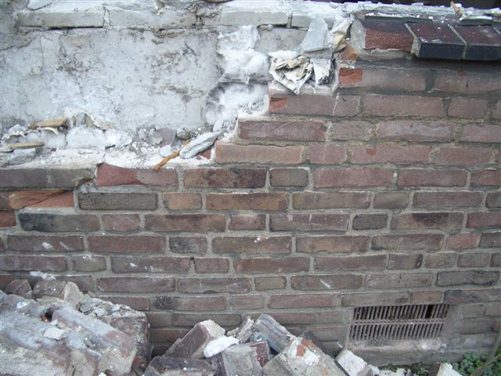
Figure 4: Demolition of masonry

In the laboratory, optimum process conditions were determined. Especially the temperature required to separate all the mortar from the brick’s surface was investigated for different brick types and different mortar systems. It appeared that for cement dominated mortars, the best temperature was around 540 ºC. However, mortar types also containing lime, require even higher temperatures. In the case of feeding big lumps of masonry debris, this leads in that case to a relatively high percentage of cracked bricks. This is caused by the fact that the critical quartz solid phase transition temperature of 573 ºC must be passed twice, leading to internal stress. This high cracking percentage can be substantially decreased by a pre treatment, in which the individual bricks are mechanically separated. This is quite easy, because these mortar types are rather weak.
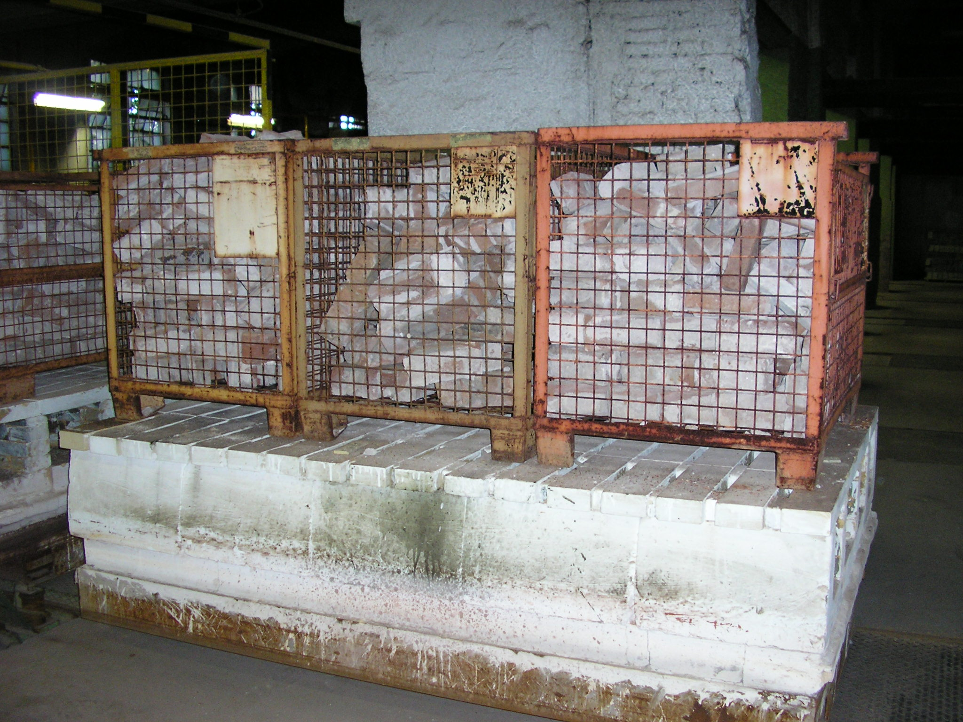
Figure 5: Masonry debris in baskets, on a kiln car

To verify the laboratory experiments, two experiments were carried out on semi-practical scale (one with a cement dominated mortar and one with a mortar also containing lime).
In the experiment with the cement-based mortar, 2.5 tonnes of masonry debris pieces were piled on kiln cars and fed into a stationary chamber kiln. The masonry debris was treated at 540°C for twenty four hours. After the thermal treatment the bricks were hand sorted. The result was: 900 kg whole bricks, 1120 kg broken bricks and brick parts, 500 kg mortar and some steel anchors. So, the recovery rate was 36% of the total mass of masonry input.

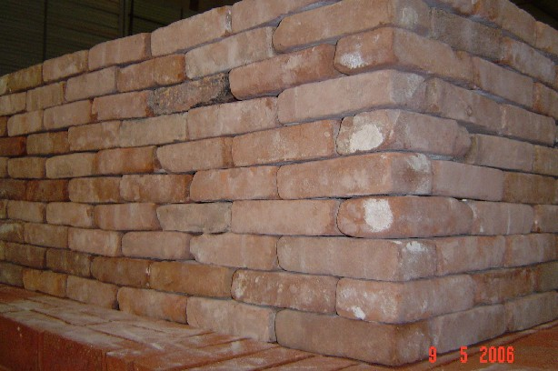

Figure 6: Recovered whole clay bricks

In the experiment with the lime-containing mortar 2200 kg of bricks were mechanically set free. The individual bricks were piled in large wire baskets, put on the kiln car, and in the same way fed into the stationary chamber kiln. This is shown in figure 5. These bricks were treated at 650 °C for 12 hours. These bricks were mechanically treated in a shaking trough, placed up front a shovel, to loosen and separate the mortar parts. The result was: 900 kg whole bricks, 850 kg broken bricks and 450 kg of bricks that were not clean. So, the recovery rate was 41% in this specific case. This is higher than in the former case, but at the cost of more thermal energy and an extra labour-intensive pre treatment.
In both cases the bricks had a grey appearance at the bottom and top side. The facing sides however, were clean. The bricks were of good technical and environmental quality, in accordance with the Dutch standard NEN 2489 (dimensions and strength), and with the Dutch Building Materials Decree (leaching of heavy metals and salts).

SEPARATION OF MIXED C&D WASTE STREAMS
Mixed C&D waste streams will have to be separated and extensively cleaned up, in order to gain enough quality to reuse the different fractions. In the Closed Cycle Construction project the aim is to end up with a decontaminated mineral aggregate fraction that can be reused in concrete and a decontaminated combustible fraction that can be used as a fuel in the thermal processes, described before. The challenge in this respect is to find the right combination of a cheap bulk separation technique (as a rough pre-concentration) and one or more automated sorting techniques for the further clean-up of the pre-concentrated fractions. This approach already proved successful in the processing of recycle glass and metallic scrap. An example is worked out in figure 7. In this example the dry density separator produces as heavies an aggregate of 98% purity and combustible lights of 80% purity. Assuming a typical concentration factor of 10 for a single stage industrial automatic sorting step, the final aggregate quality will be of 99.8 % purity and the lights will have 98% purity. Light materials that are unsuitable for combustion in conventional processes, such as PVC, can be concentrated in a separate waste stream.

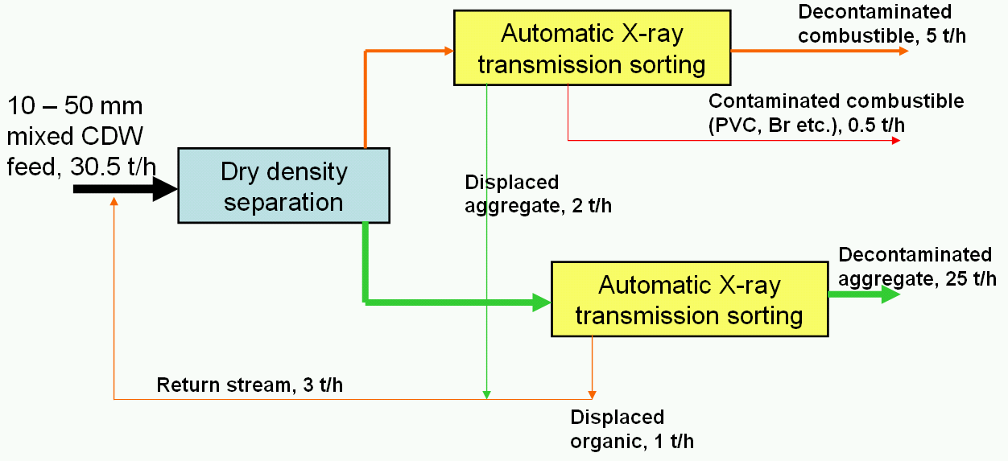
Figure 7: Principle of pre-concentration and decontamination with X-ray sorting

Dry separation techniques
With regard to the pre-contamination of the mixed C&D waste stream, several dry density separation techniques were investigated experimentally, on a pilot scale (Jong & Fabrizi 2004). All investigated separators showed variable but satisfactory efficiency. The best choice depends on a trade off between economy and required product quality, and on factors such as space requirements, capacity requirements, whether or not classification in narrow size fractions is possible, etc. The tests resulted in sufficient quantitative data to support a tailor made decision for a given operation.
The dry sand fluidised bed shows the highest product purities for 20 mm oversize and obtains product qualities that are similar to wet jigging. The principle ability to separate coarse material (larger than 50 mm) is unique for this dry technology and is of high relevance for C&D waste sorting. Unfortunately separation of larger sizes then 40 mm could not be investigated in the present project due to practical limitations of the applied equipment. Disadvantage is sand loss in the product and the lower efficiency for finer material (5 to 20 mm). However, in aggregates a certain sand level is tolerated and in combustible fractions it causes only a minor increase in ash content.
Although of lower separation efficiency, the air jig provides a favourable solution when prior classification into several size fractions is impractical and a significant fines percentage (2 to 20 mm) is present, for which the fluidised bed is unsuitable. Both separators would also work well together, the jig treating the material up to 30 mm, the fluidised bed the 30 mm oversize. Prior removal of lights and fines with air sifting is recommended.
Ballistic separators and air tables require prior classification into rather narrow particle size fractions. A high screening efficiency is of paramount importance. For damp feed appropriate screening technology must be applied. Air tables show additional displacement of tile and glass fragments in the lights. Ballistic separation is very suitable as high volume pre-concentration wherever narrow classification can be done and there is sufficient head-room available.

Automatic sorting techniques
With regard to the automatic sorting techniques, required for the further clean-up of the pre-concentrated fractions, two techniques have been extensively investigated (de Jong et al. 2005). Both techniques have their own advantages.
Automatic colour sorting of the light and heavy fractions was investigated with the Scan & Sort CombiSense 1200 at the Department of Mineral Processing at RWTH Aachen, Germany. Its optical system incorporates a high-speed camera with 1 billion colours recognition and a special conductivity sensor permitting the identification of a variety of materials (see figure 8). It can handle mass streams of up to 40 tonnes per hour. Computer controlled nozzles blow out the detected materials. The camera is analyzing size, shape, colour and position of particles on the belt. The information is then used to generate impulses instructing the nozzles to blow out single particles or allow them to pass.
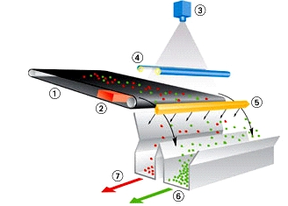
Figure 8: Principle of colour sorting (Scan & Sort) 1=conveyor, 2=metal sensor, 3=colour camera, 4=lighting, 5=blow bar, 6=main stream, 7=reject

The results gained with the CombiSense exceeded expectations. It could well be used to increase product quality and avoid the presence of unwanted materials in the stream to be recycled.
Total wood recovery and grade from the light fraction are high, reaching values of 83% and 92% respectively. 3% of stones and tiles are separated with wood; by more effective density separation a large proportion of this heavy material could be removed and grade would be about 95%. It can be concluded that colour sorting can be effectively used for wood removal from mixed CDW.
Colour sorting also allows a good removal of gypsum form the heavy fraction showing a recovery of 94%. This is a good result because in recycle aggregate the presence of that mineral should be avoided due to its sulphate content. The grade is only 5.6% because of the presence of stones and tiles of similar colour in the concentrate. These could be easily removed by density separation in a second stage.
Glass recovery and grade are 96% and 56%. Thus the CombiSense separator would be also useful for glass removal from mixed building waste, where glass comprises the disturbing component.

A second automatic sorting technique that was investigated in the project, is a sorting based on Dual-energy X-ray transmission. On a lab-scale preliminary experiments were carried out, to ‘image’ the different components in mixed C&D waste. In figure 9 is shown that an effective split can be made between organic and inorganic materials, as well as an effective metal recognition in the same pass. Utilising dedicated imaging software specific components such as gypsum or asbestos can be removed as well.

Figure 9: Concentration of components in CDW using X-ray transmission imaging

In addition to the lab-scale experiments mentioned above, experiments were carried out with DE-X-ray sorting, on a larger scale (1 to 2 m³). Also here the main conclusion is that this type of automatic sorting is especially useful for the separation of organic and inorganic materials. Especially the sorting of wood at high purity and recovery is possible. Metal separation, also of parts that contain only smaller metal inserts, is well possible in addition.
As preparation for the tests the material (mixed C&D waste) was screened in a 20 X 40 mm and 40 X 80 mm fraction. The smaller and larger material was not sorted. The < 20 mm material was only a small fraction; the fractions > 80 mm cannot be sorted on the available DE-XRT sorter due to limitations in geometry and air jets. This is not a principle limitation, but a limitation of the experimental device.
The fractions of C&D waste were analysed on composition in the categories wood, stone, glass, gypsum, metal, plastic, textile, paper & cardboard and others (“rest”). The DE-XRT sorting machine that was available at CommoDas GmbH in Wedel, Germany, was adjusted and trained to concentrate wood in the usual way.
The composition of the 20 X 40 mm input material and the component split after sorting are given in tables 1 and 2 respectively. The component split indicates the recovery; e.g. 43% of the input feed is recovered as wood in the wood concentrate, that is 47% of the feed input. The remaining 4% of wood is lost in the reject. The results of the 40 X 80 mm fraction are more or less comparable.

Table 1. Feed characterization of fraction 20 – 40 mm.

Fraction | Amount in input material
 | Weight [g] | Wt% [g/g]
Wood | 9837 | 47.2
Stone | 8109 | 38.9
Glass | 590 | 2.8
Gypsum | 264 | 1.3
Metal | 569 | 2.7
Plastic | 929 | 4.5
Textile | 230 | 1.1
Paper / cardboard | 66 | 0.3
Rest < 20 mm | 271 | 1.3
Total | 20863 | 100.0

Table 2. Component split after sorting.

Fraction | Component split
 | Product [%] | Reject [%]
Wood | 42.7 | 4.4
Stone | 0.4 | 38.4
Glass | 0.1 | 2.8
Gypsum | 0.0 | 1.3
Metal | 0.1 | 2.6
Plastic | 1.6 | 2.8
Textile | 0.7 | 0.4
Paper / cardboard | 0.3 | 0.1
Rest < 20 mm | 0.9 | 0.4
Total | 46.8 | 53.2

The test results indicate that from mixed C&D waste in the 20 to 80 mm size range a wood fraction can be sorted out with an excellent quality for re-use as a secondary fuel, and without any pre-treatment other than screening and sifting.

BENEFITS OF ‘CLOSED CYCLE CONSTRUCTION’
The new concept as a whole has several advantages. The most illustrative advantages are:
- Closing the material cycles for concrete and masonry within their own chain. With regard to the framework of sustainable development, this fulfils one of the objectives of the Dutch government. It also fits into the industries policy of producer’s responsibility and long-term raw materials availability.
- Recovery of high-grade raw materials for the production of new concrete and ceramic bricks means higher profits for the C&D waste treatment industry, because of higher prices for their products. The production of high-grade raw materials also reduces the excavation of primary materials, such as sand, gravel, clay and marl.
- Utilising the combustible fraction of demolition waste as a fuel doubles the environmental profit. First, in reducing the amount of waste to be disposed of, and second in reducing the amount of fuel that is required for the thermal treatment of concrete and masonry rubble.
- Re-use of the recovered cement stone fraction in the production of new cement (as replacement of part of the Portland cement clinker) leads to less excavation of marl, and less carbon dioxide emissions.
- The integrated character of the process finally implies a reduction in transport costs. This means less fuel consumption and less exhaust gases.

References
Dijk, K. van 2002. Closing the clay brick cycle (thesis), ISBN 90-90 17911-9, AVDS b.v., Noordwijk, the Netherlands.
Jong, T.P.R. de & Fabrizi, L. 2004. Dry separation of mixed construction and demolition waste, Recycling International, December 2004: 24 – 27.
Jong, T.P.R. de, Fabrizi, L. &. Kuilman, W. 2005. Dry density separation of mixed construction and demolition waste, presentation for the 2005 Sortierkolloquium, TU Berlin.
Larbi, J.A., Heijnen, W.M.M., Brouwer, J.P. & Mulder, E. 2000. Preliminary laboratory investigation of thermally treated recycled concrete for general use in concrete. In Woolley, G.R., Goumans, J.J.J.M. & Wainwright, J.P. (eds.), Waste Materials in Construction; Proc. Wascon 2000 intern. Conf., Harrogate, UK: 129-139, Pergamon.
Mulder, E., Blaakmeer, J., Tamboer, L. & Nijland, T.G. 2002. A closed material cycle for concrete, as part of an integrated process for the reuse of the total flow of C&D waste. In Dhir, R.K., Dyer, T.D. & Halliday, J.E. (eds), Sustainable Concrete Construction; Proc.International Conference ‘Challenges of Concrete Construstion’, Dundee, September 2002: 555 - 562. London, England: Thomas Telford Publishing.
Shima, H., Tateyashiki, H., Nakato, T., Okamoto, M. & Asano, T. 1999. New technology for recovering high quality aggregate from demolished concrete, Paper presented on the Fifth International Symposium on East Asian Recycling Technology, June 15-17, Tukuba, Japan, Proceedings pp. 106-109.

