Concrete paving products made with recycled demolition aggregates
K. Tang, M.N. Soutsos & S.G. Millard
Department of Engineering, University of Liverpool, Liverpool, L69 3GQ, UK

ABSTRACT: The potential for using construction and demolition waste (C&DW) derived aggregate in the manufacture of concrete paving blocks is being investigated at the University of Liverpool. Market research indicated that economic benefits might be achieved by using recycled demolition aggregates in precast concrete paving products. The mechanical properties, i.e., compressive and tensile splitting strength, of paving blocks made with recycled demolition aggregates were also investigated. Levels of aggregate replacement were determined that produced blocks with similar mechanical properties to those of blocks made using only natural aggregates, without requiring an increase in the cement content.

INTRODUCTION

In 1999, C&DW in the EU amounted to 450 million tonnes [Symonds, 1999], approximately 25% of all waste generated that year. Only 25% of this C&DW was recycled or re-used. In 2005, the UK produced 72.5 million tonnes of C&DW [EIONET, 2005] (including excavated soils) of which only 35% was recycled [Communities and local government, 2005]. During this time, 270 million tonnes of quarried aggregates were extracted [ODPM, 2006]. As a waste reduction measure, the UK Government aims to increase the use of recycled and secondary aggregates from 40 million tonnes up to 55 million tonnes by 2006 and up to 60 million tonnes by 2011 [Collins et al. 2005]. Recycled aggregates are currently used primarily for low-grade applications such as granular sub-base of road pavements. There is therefore a need to investigate a high value market for C&DW derived aggregates.
As precast concrete paving blocks are low-profit-margin products, block-making factories will be interested in C&DW derived aggregates if the price is lower than that of quarried aggregate. The price of natural aggregates (see Table 1) is likely to increase, especially after the introduction of the Aggregate Levy Tax. This will encourage companies to consider using recycled demolition aggregate which will almost certainly be cheaper. In areas such as North West England, where precast factories are situated close to urban areas and local natural aggregate resources are limited [Soutsos et al. 2004], use of recycled demolition aggregates may also reduce transportation costs. Concrete paving blocks were selected for investigation for the following reasons:
- High usage. It is estimated that 100 square feet (≈ 9m²) per person of paving blocks are installed annually in Europe [Concrete network, 2006].
- The risk of steel corrosion damage resulting from chloride contaminated C&DW will not be an issue because conventional paving blocks are not reinforced with steel.
- The production of concrete paving products is a manufacturing process where the supply and storage of materials is more easily managed than with concrete used for in-situ construction.

Table 1. Supplier gate price for quarried aggregates used in concrete paving blocks.
 | £/tonne
6mm limestone  (20% of total aggregate) | 8.00 to 10.00
Medium grading sand  (80% of total aggregate) | 6.00
Total cost of importing quarried aggregates | 6.40 to 6.80

The use of crushed concrete- and masonry-derived aggregates to replace both coarse and fine natural aggregates in concrete building blocks has already been investigated at the University of Liverpool [Soutsos et al. 2004]. Building blocks using up to 60% replacement of quarried coarse aggregate with concrete-derived C&DW aggregate achieved a similar compressive strength to those made using 100% quarried limestone aggregate, without requiring an increase in the cement content. Poon and Chan studied the use of recycled crushed clay brick and recycled concrete aggregate in the manufacture of concrete paving blocks [Poon et al,. 2006]. The paving blocks had a compressive strength between 25 and 63 MPa at 28 days, depending on the percentage of recycled material used. Both studies also showed a different detrimental influence on the mechanical properties depending on whether recycled concrete- or recycled masonry-derived aggregates were used. For this reason, recycled concrete and recycled masonry were investigated separately in this project.

Available of C&DW-derived aggregate

The market demand for C&DW-derived aggregates can be assured in an urban area such as Liverpool, where on-going replacement of infrastructure is associated with high costs of C&DW disposal. Currently, demolition of around 20,000 houses is planned in Merseyside as part of a ‘housing market renewal’ [Clover, 2005] scheme. As part of a regeneration plan to build a dual carriageway road into Liverpool city centre, hundreds of houses will be demolished by 2008 [BBC, 2006].
The concrete C&DW that was crushed to produce aggregate for this study came from a reinforced concrete tower block (see Fig. 1). The masonry C&DW came from the demolition of a row of council houses (see Fig. 2). Demolition waste material was transported and crushed at a local crushing plant. The crusher was unable to crush all of this material into the required size despite utilizing a ‘choke feed’ technique [Soutsos et al. 2004]. Even with this technique only 30% of the total demolition material supplied was crushed to the required coarse (6 mm) and fine (4 mm to dust) aggregate size.
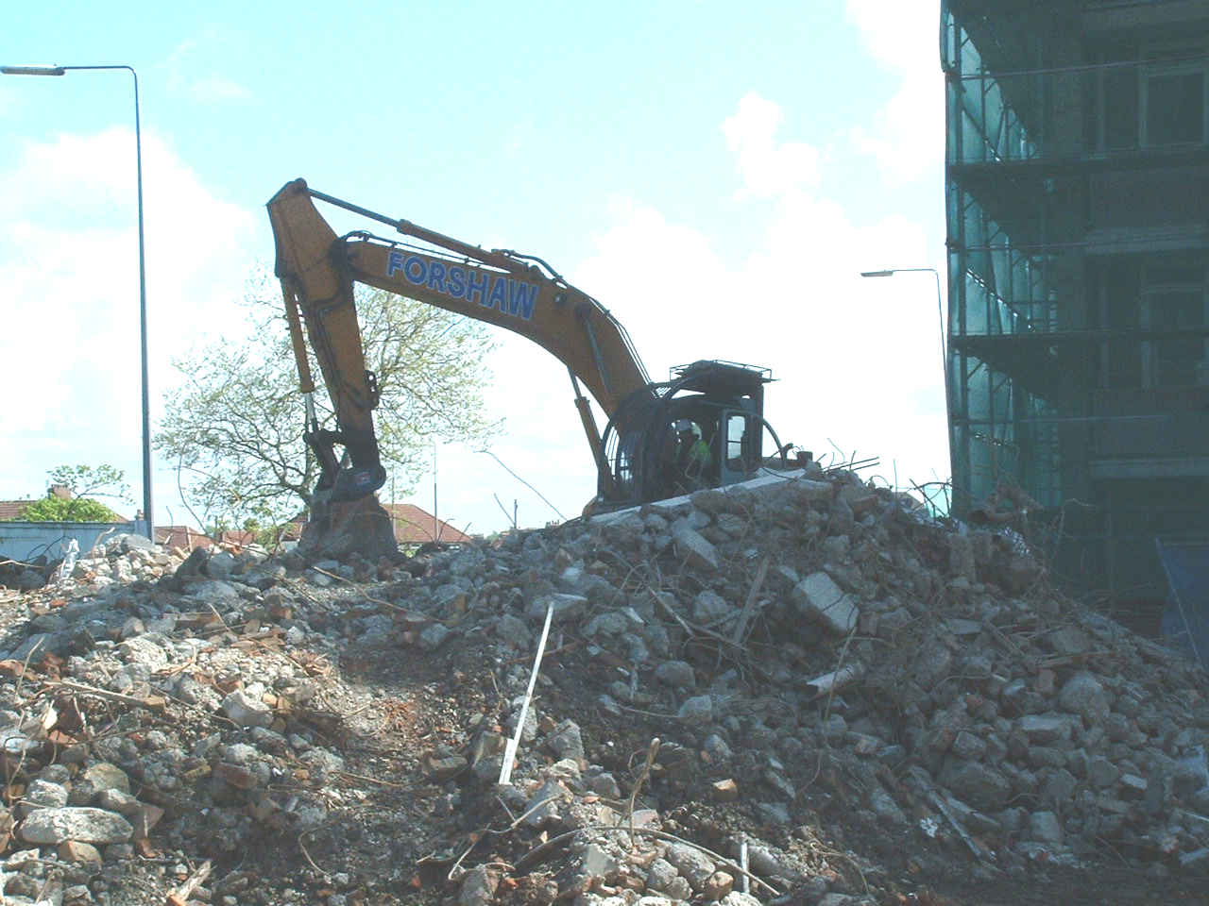
Figure 1. Demolition of a reinforced concrete tower block.

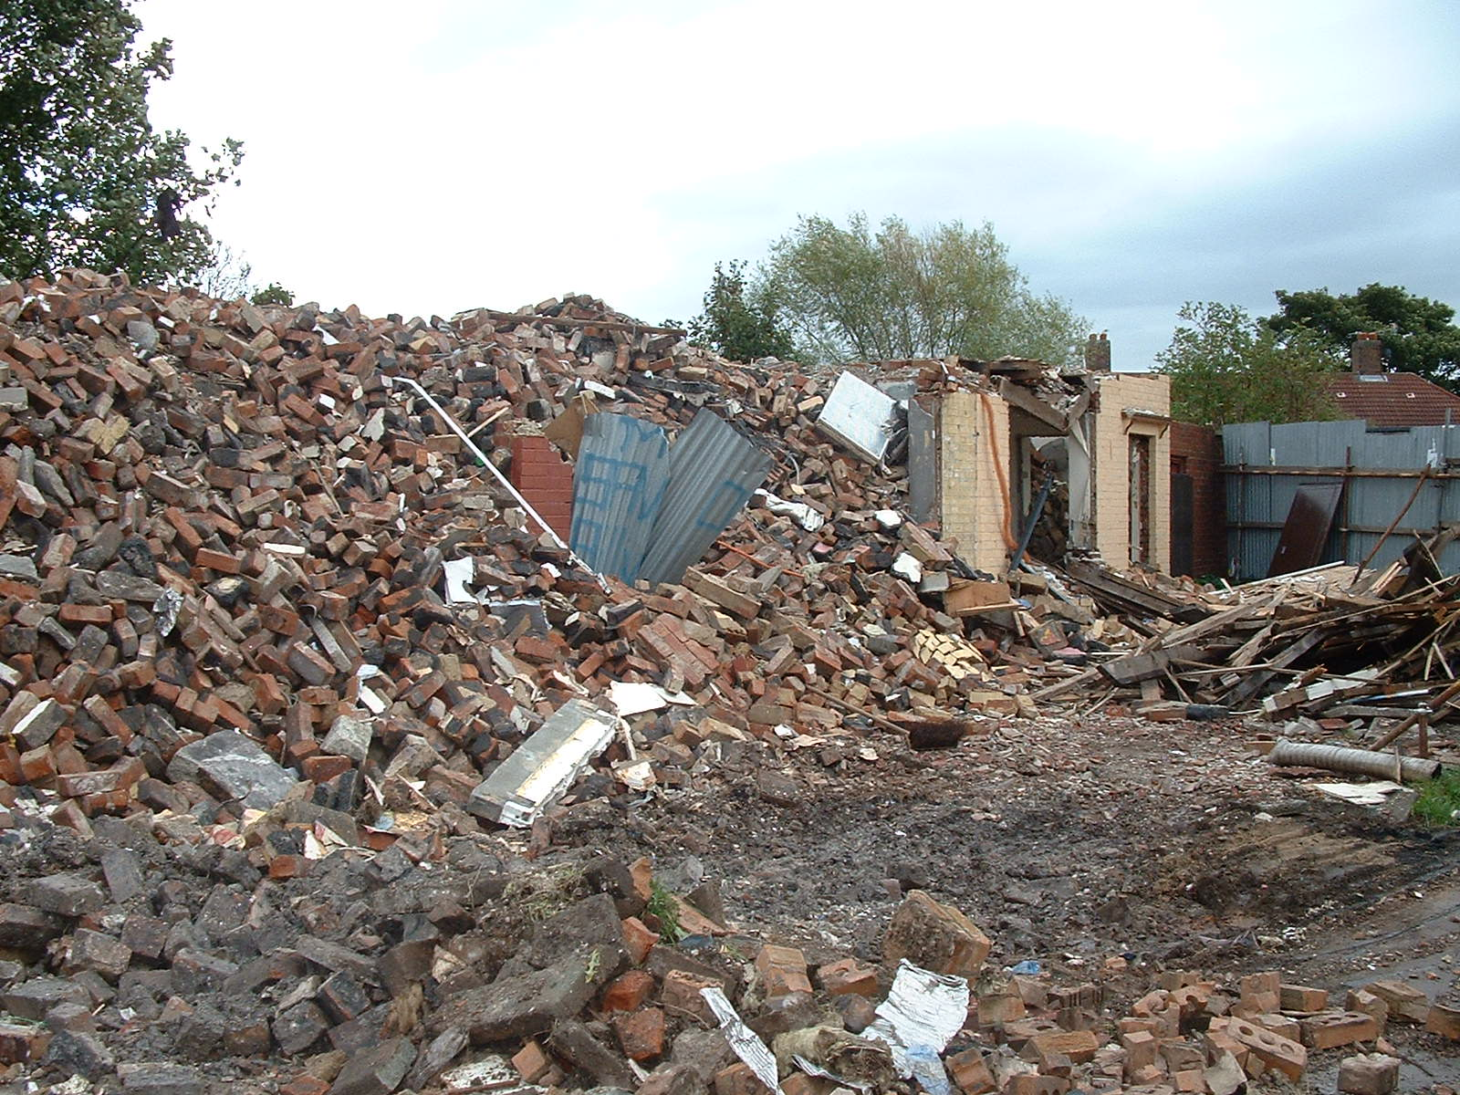
Figure 2. Demolition of a masonry council house.

Materials & experimental methods

Recycled aggregates used in this project
The use of recycled aggregate in designated concrete mixes is now permitted by BS 8500-2:2002 [BSI, 2002]. This is the first UK specification for the use of C&DW derived aggregates in concrete. The grading of 6 mm recycled aggregate from both concrete and masonry demolition waste was found to be similar to that of quarried limestone (see Fig. 3). However, recycled 4 mm-to-dust aggregate derived from masonry demolition waste was found to be significantly finer than natural medium graded sand. The converse was found to be true for fine recycled aggregate derived from concrete demolition waste (see Fig. 3). Recycled aggregate from both concrete and masonry demolition wastes had a much higher water absorption and a lower density (see Table 2). The lower density and higher water absorption of C&DW-derived aggregates were expected to be problematic [Soutsos et al. 2004].

Figure 3. Sieve grading of natural aggregate and C&DW derived aggregate.

Preliminary trials – development of “vibro-compaction” technique

The block-making industry uses a heavy vibrating compactor to compress the concrete into a block mould. In the first phase of the project, the factory procedure was replicated in the laboratory by using a vibration hammer to compact the concrete from above. However, preliminary trials using a range of water-cement ratios indicated that, despite using similar mix proportions to the factory, the target compressive and tensile splitting strengths of 49 MPa and 3.6 MPa, respectively, were not achieved. A study of the compressive strength results also indicated that for a water-cement ratio below 0.30, full compaction was not achieved (see Fig. 4). Another approach was investigated to improve the compaction, which involved increasing the compressive force and dispensing with vibration. A pressure of up to 15 N/mm² was applied to the fresh concrete to compact the specimens. The resulting low compressive strength indicated that compression alone was insufficient and that simultaneous compression and vibration was necessary to achieve the required compaction.
Efforts were then focused on modifying the existing frame used with the vibration hammer to enable compression and vibration from both above and below. A small metal table was converted to a vibrating table by attaching a clamp-on-vibrator. This table was used in conjunction with the vibration hammer so that specimens could be vibrated above and below, while they were being compacted (see Fig. 5). The use of this combined vibro-compaction technique, together with the use of a superplasticiser, enabled the wet density of paving blocks to be increased from 2230 kg/m³ (achieved by vibro-compaction only) to 2390 kg/m³. Compressive strengths greater than 49 MPa and tensile splitting strengths greater than 3.6 MPa were achieved at 28 days. The original texture of concrete paving blocks cast in the laboratory using the improved vibro-compaction technique compared well with that of paving blocks obtained from the factory (see Fig. 6).

THE EFFECT OF RECYCLED DEMOLITION AGGREGATE ON THE MECHANICAL PROPERTIES OF COCNRETE PAVING BLOCKS

Series I: Concrete-derived C&DW aggregate
After successfully replicating the industrial block-making procedure in the laboratory, the replacement of quarried limestone with concrete-derived C&DW aggregates was studied. The mix proportions of the control mix using only natural aggregates was converted to a volumetric ratio and natural aggregate was replaced by an equal volume of C&DW-derived aggregate. This volumetric replacement approach allows for the different density of recycled aggregates and enables production of blocks of the same physical size from different mixes (see Table 3 & 4). Each series of mixes commenced with an initial cement content of 230 kg/m³. This was incrementally raised to 380 kg/m³ to yield specimens with a range of cement contents but the same replacement aggregate ratio.
It was thought that the fine aggregate, i.e., 4 mm-to-dust, would have the most detrimental effect on compressive strength [Soutsos et al. 2004]. Studies were planned using a replacement of either coarse or fine aggregate alone, to quantify the relative effects of each.
Concrete paving blocks use a high ratio of 4:1 fine/coarse aggregate in order to achieve a high-quality surface finish. It was found that a reduction in the water-cement (W/C) ratio was required to obtain a comparable compressive strength for a block using concrete-derived aggregate (see Fig. 7). A reduction in the water-cement ratio also necessitated an increase in the cement content to obtain a high-quality surface finish. It appears that the consistency of the mix is dependent on the FREE water content, i.e., the FREE water content needs to be constant for all water-cement ratios. This observation is consistent with the design of normal concrete mixes. The total water content will of course increase to account for the higher percentages of water absorption of the recycled demolition aggregate.
Fig. 8 shows that the detrimental effect on the compressive strength from replacing natural fine aggregates with concrete-derived C&DW aggregates is relatively small, with a reduction 10% in the 28-day strength at a replacement level of 75%. However, the resulting tensile strength showed considerable variability and hence a conservative recommendation of a maximum replacement level of 60% for fine concrete-derived C&DW aggregates is made. Further experimental work is being conducted to investigate the combined use of both coarse and fine concrete derived C&DW aggregates. It is to be hoped that these studies will confirm and further increase confidence in the above replacement level recommendations.

Figure 4. Compressive strength (7-day) vs water-cement ratio, using vibration compaction from above.

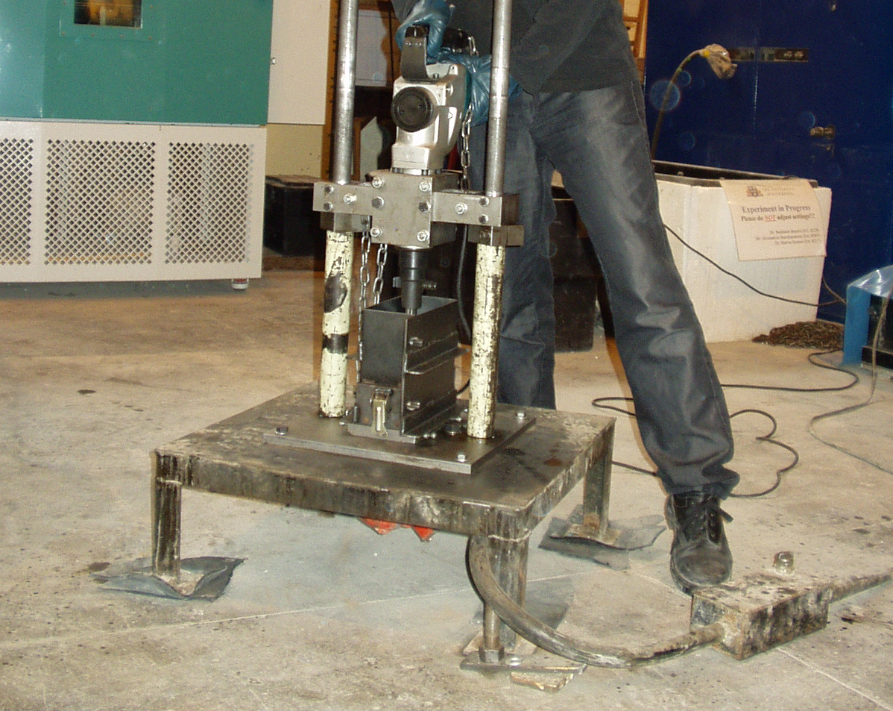
Figure 5. Combination of vibrating table and vibration hammer to cast concrete paving blocks.

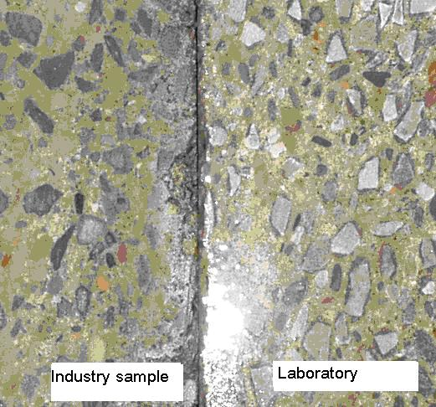
Figure 6. Cross-section texture: industry and laboratory cast specimens.

Table 2. Relative density and water absorption (% of dry mass).
 | Fine aggregate |  |  | Coarse aggregate
 | Sand | Concrete | Masonry | Limestone | Concrete | Masonry
Relative density (Saturated and Surface Dry) | 2.44 | 2.25 | 2.42 | 2.69 | 2.38 | 2.26
Relative density (oven dry) | 2.41 | 1.82 | 2.01 | 2.67 | 2.27 | 2.11
Moisture Absorption | 1.5 | 13.56 | 13.42 | 0.65 | 7.24 | 8.83

Table 3. Mix proportions (kg/m³) for concrete paving blocks – Replacement of coarse natural aggregate with masonry-derived coarse aggregate.
Mix Type | Cement | Coarse Aggregate  (6 mm) |  | Fine Aggregate  (4 mm-to-dust) |  | Free  W/C
Mix Type | Cement | Limestone | Masonry | Sand | Masonry | Free  W/C
Control (100% quarried aggregate) | 230 | 380 |  | 1521 |  | 0.39
Control (100% quarried aggregate) | 305 | 380 |  | 1521 |  | 0.36
Control (100% quarried aggregate) | 380 | 380 |  | 1521 |  | 0.33
25% Coarse replaced | 230 | 285 | 80 | 1520 |  | 0.48
25% Coarse replaced | 305 | 285 | 80 | 1520 |  | 0.40
25% Coarse replaced | 380 | 285 | 80 | 1520 |  | 0.39
50% Coarse replaced | 230 | 190 | 160 | 1520 |  | 0.47
50% Coarse replaced | 305 | 190 | 160 | 1520 |  | 0.39
50% Coarse replaced | 380 | 190 | 160 | 1520 |  | 0.36
75% Coarse replaced | 230 | 95 | 240 | 1520 |  | 0.42
75% Coarse replaced | 305 | 95 | 240 | 1520 |  | 0.35
75% Coarse replaced | 380 | 95 | 240 | 1520 |  | 0.33
100% Coarse replaced | 230 |  | 319 | 1520 |  | 0.39
100% Coarse replaced | 305 |  | 319 | 1520 |  | 0.33
100% Coarse replaced | 380 |  | 319 | 1520 |  | 0.32
Table 4. Mix proportions used for concrete paving blocks – Replacement of fine fraction of aggregates with concrete-derived aggregates.
Mix Type | Cement | Coarse Aggregate  (6 mm) |  | Fine Aggregate  (4 mm-to-dust) |  | Free  W/C
Mix Type | Cement | Limestone | Concrete | Sand | Concrete | Free  W/C
Control (100% quarried aggregate) | 230 | 380 |  | 1521 |  | 0.39
Control (100% quarried aggregate) | 305 | 380 |  | 1521 |  | 0.36
Control (100% quarried aggregate) | 380 | 380 |  | 1521 |  | 0.33
25% Fine replaced | 230 | 380 |  | 1140 | 351 | 0.38
25% Fine replaced | 280 | 380 |  | 1140 | 351 | 0.35
25% Fine replaced | 330 | 380 |  | 1140 | 351 | 0.33
25% Fine replaced | 380 | 380 |  | 1140 | 351 | 0.31
50% Fine replaced | 230 | 380 |  | 760 | 701 | 0.41
50% Fine replaced | 280 | 380 |  | 760 | 701 | 0.37
50% Fine replaced | 330 | 380 |  | 760 | 701 | 0.35
50% Fine replaced | 380 | 380 |  | 760 | 701 | 0.33
75% Fine replaced | 230 | 380 |  | 380 | 1052 | 0.39
75% Fine replaced | 280 | 380 |  | 380 | 1052 | 0.36
75% Fine replaced | 330 | 380 |  | 380 | 1052 | 0.34
75% Fine replaced | 380 | 380 |  | 380 | 1052 | 0.33
100% Fine replaced | 230 | 380 |  |  | 1402 | 0.42
100% Fine replaced | 280 | 380 |  |  | 1402 | 0.38
100% Fine replaced | 330 | 380 |  |  | 1402 | 0.36
100% Fine replaced | 380 | 380 |  |  | 1402 | 0.34

a) Compressive strength b) Tensile splitting strength
Figure 7. Effect of W/C on 7-day strength of blocks using different replacement levels (%) of concrete-derived fine aggregate.

a) Compressive strength b) Tensile splitting strength
Figure 8. Effect of replacement level (%) on strength of blocks using concrete-derived fine aggregate.
(All mixes contained 380 kg/m³ of cement. The free water had to be increased with increasing replacement levels to maintain the same workability).

a) Compressive strength b) Tensile splitting strength
Figure 9. Effect of water cement ratio on 7-day strength of blocks using different replacement levels (%) of masonry-derived coarse aggregate.

a) Compressive strength; b) Tensile splitting strength
Figure 10. Effect of replacement level (%) on strength of blocks using masonry-derived coarse aggregate.
(All mixes contained 380 kg/m³ of cement. The free water had to be increased with increasing replacement levels to maintain the same workability).

Series II: Masonry-derived C&DW aggregate

The replacement of newly quarried limestone aggregate with masonry-derived C&DW aggregate was investigated separately from concrete-derived aggregate.
It was again found that a lower W/C is needed if blocks made using masonry-derived C&DW aggregate are to have the same strength as blocks using quarried limestone. A lower W/C also necessitated an increase in cement content. The dependence of the mix consistency on the free W/C using masonry-derived C&DW aggregate was similar to that observed using concrete-derived aggregate (see Fig. 9). It was concluded that a replacement level of up to 60% for the coarse masonry derived aggregate could be recommended (see Fig. 10).

Conclusions
With the introduction of the Aggregate Levy Tax, economic benefits might be achieved from using recycled demolition aggregates in the manufacture of precast concrete paving blocks. Concrete paving blocks, with a replacement of up to 60% of coarse natural aggregates with recycled masonry-derived aggregates, can still achieve equivalent strength without the need for increased cement content. It was also concluded that a replacement of 60% of the fine natural aggregate with concrete-derived aggregates could be recommended.

Acknowledgements
The authors wish to thank the Veolia Environmental Trust and the Flintshire Community Trust Ltd. (AD Waste Ltd.) for funding this project. The authors are also grateful to the following industrial collaborators for their assistance: Clean Merseyside Centre, Mashalls Ltd., Forticrete Ltd., Liverpool City Council, Liverpool Housing Action Trust, RMC Readymix Ltd., W.F. Doyle & Co. Ltd. and DSM Demolition Ltd.
REFERENCES
Symonds. 1999. Construction and Demolition Waste Management practices and their economic impacts. Report to DG XI. European Commission.
EIONET. Construction and demolition waste. <http://waste.eionet.eu.int/waste/4> European Environment Agency (28/08/05).
Communities and local government. Construction and demolition waste survey: England and Wales 1999/2000 Summary. <http://www.communities.gov.uk/index.asp?id=1143366> (15/07/05).
British Geological Survey. Construction aggregates. <http://www.mineralsuk.com/britmin/mpfaggregates.pdf> British Geological Survey (15/7/2006)
Collins, R J, Dunster, R J & Kennedy, J. 2004. Improving Specifications for use of Secondary and Recycled Aggregates in Construction: Research Report. <http://www.aggregain.org.uk/templates/temp_agg_publication_details.rm?id=2298&publication=1869> The Waste & Resources Action Programme (WRAP) (28/08/05).
Soutsos, M. N., S. G. Millard, J. H. Bungey, N. Jones, R. G. Tickell, and J. Gradwell. 2004. Using recycled demolition waste in concrete building blocks. Proceedings of the Institute of Civil Engineers: Engineering Sustainability 157(3):139-148.
Concrete network. Concrete pavers. <http://www.concretenetwork.com/concrete/pavers/index.html> (1/9/2006).
Poon, C.S. & Chan, Dixon. 2006. Paving blocks made with recycled concrete aggregate and crushed clay brick, Construction and building materials, 20 (2006): 569-57.
Clover, Charles. 2005. Prescott's bulldozers ready to demolish Victorian terraces. <http://www.telegraph.co.uk/news/main.jhtml?xml=/news/2005/01/29/npres29.xml> Telegraph (1/5/2006)
BBC. Homes demolition plan challenged. <http://news.bbc.co.uk/2/hi/uk_news/england/merseyside/4842686.stm> British Broadcasting Corp. (1/5/2006)
British Standards Institution. 2002. Concrete – Complementary British Standard to BS EN 206-1, Part 2: Specification for constituent materials and concrete. BSI, London, BS 8500-2:2002.
British Standards Institution. 2003. Concrete paving blocks – Requirements and test methods. BSI, London, BS EN 1338: 2003.

